**Task 3: Deploy your ASP.Net Core application with Docker.**

1) In your project’s root folder create a .Dockerfile with all the necessary instructions.

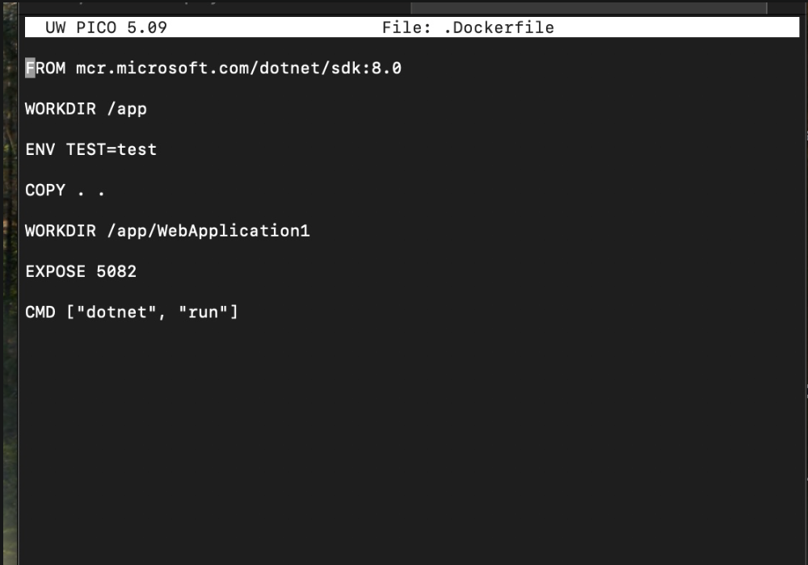

2) Build an image from your newly created Dockerfile via command line.

3) Build and run a container from your newly built image.

4) Push the image you just created into Azure Container Registry or Docker Hub so that your mentor can download  and run it.

5) Login to [Azure Portal](https://portal.azure.com/) and verify all resources were created. Find your App Service and open the app link on the browser to verify it is up and running as expected.

<http://webapi.hrgcchhuacbpcyc5.canadacentral.azurecontainer.io:5082/swagger/index.html>

